Installation Guide Cartridge SFRA

# Import Cartridge

Import **int_katapult_SFRA** and **int_katapult_core** into your Workspace inside the **cartridges** folder Modify the Site Path in **Business Manager > Administration > Manage Sites > 'Your Site' > Settings**.

Make sure the cartridge name **int_katapult_SFRA:int_katapult_core** appear before any other cartridges

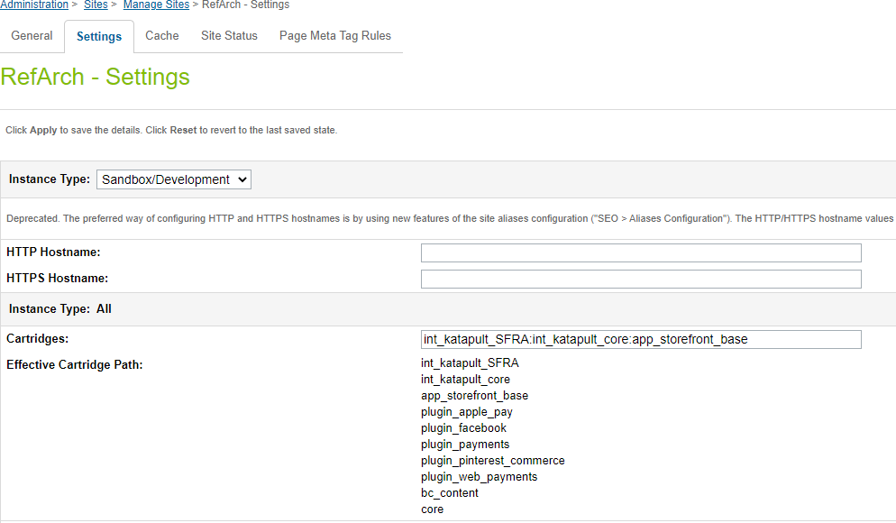

If using Visual Studio code, use the below **dw.json** format to upload the cartridges to the sandbox. Place it at the root of the working directory.

{

"hostname": "your-sandbox-hostname.demandware.net", "username": "your_user",

"password": "your_password",

"code-version": "version_to_upload"

}

# Set the Cartridge to Compile Front-end

Make sure that the cartridge it's a part of the compilator inside of the webpack.config.js

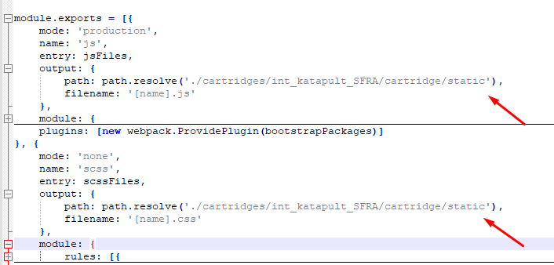

# Compile Front-end

Run the command **npm run compile:js** to compile front-end scripts. Run the command **npm run compile:scss** to compile front-end styles. **Import Metadata**

Locate folder **katapult_site_import** inside **metadata** folder, change site name if needed inside **sites** folder and compress the **katapult_s ite_import** folder to **katapult_site_import.zip**

Log in to the **Business Manager**

# Click Administration > Site Development > Site Import & Export

Use the upload control to browse the **katapult_site_import.zip** file located in the **metadata** folder Click **Upload**

Select the **katapult_site_import.zip** and click Import, press OK on the confirmation alert. Import should complete successfully

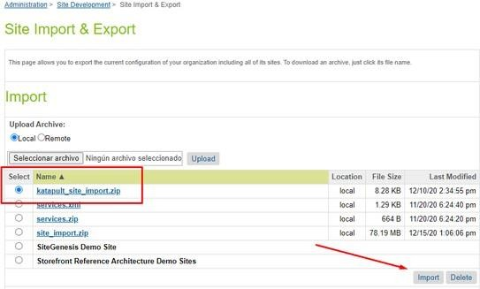

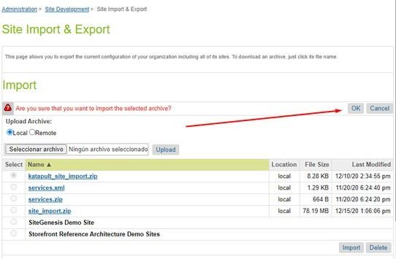

# Configure Katapult Services

Make sure that the Katapult services have been imported as part of site import step performed above. Below service configurations should be present in the Services section, **Administration > Operations > Services**

Make sure that the service URL used is one of the following, depending on whether the sandbox is a production or development, :

**Sandbox** : [https://sandbox.katapult.com](https://sandbox.katapult.com/)

**Live** : [https://www.katapult.com](https://www.katapult.com/)



**DO NOT** modify service name(s) of any of the services

Below are the screenshots for reference.

# Credentials:

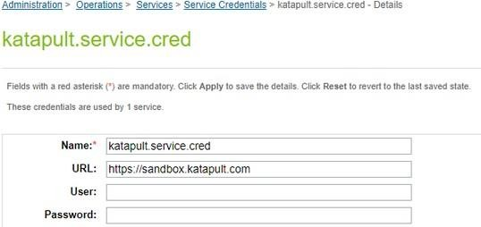

**Profile**:

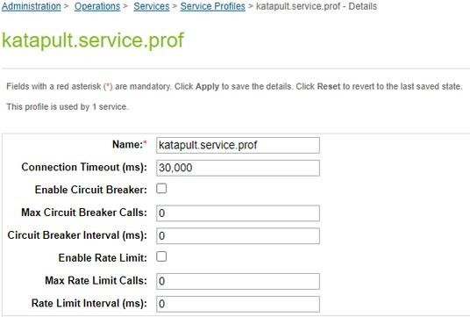

# Service:

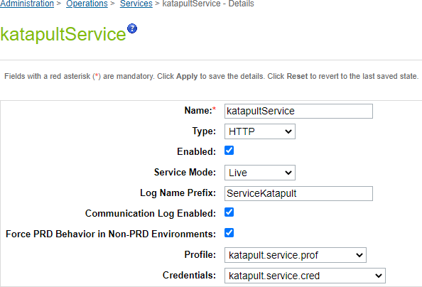

**Configure Katapult Custom Preferences**

Make sure that the **Katapult Custom Preferences** have been imported as part of site import step performed above. Below **Custom Preferences** configurations should be present in **Merchant Tools > Site Preferences > Custom Preferences**.

Select the **Katapult** Group

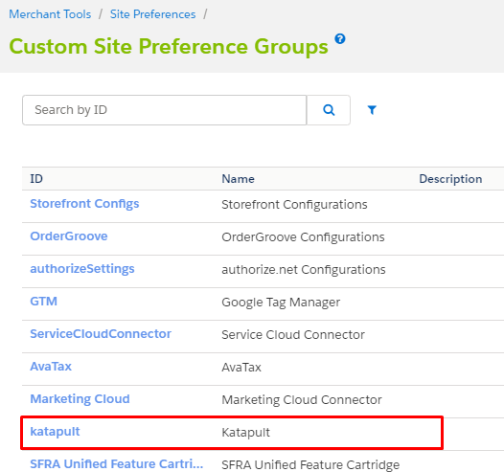

Fill the input fields with the information required

**KAT_APIToken**: Token to connect with the Katapult API

**KAT_environment**: Link for the Katapult environment (Sandbox or Live)

**Sandbox** : [https://sandbox.katapult.com](https://sandbox.katapult.com/)

**Live** : [https://www.katapult.com](https://www.katapult.com/)

**KAT_minValue**: Minimum value to proceed with Katapult Payment Method

**KAT_maxValue**: Maximum value to proceed with Katapult Payment Method

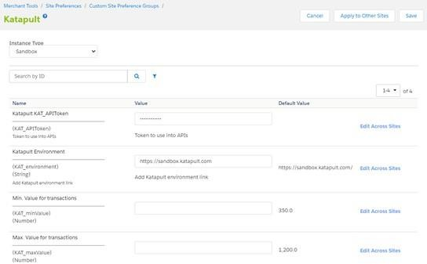

# Product Configuration to Use Katapult Payment Method

First verify that the product selected is leasable, go to **Business Manager** and **Merchant Tools > Products and Catalogs > Products**

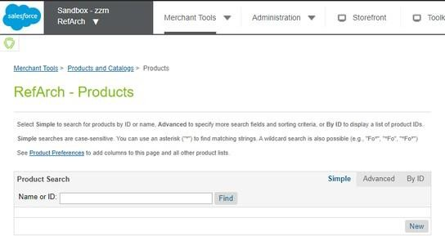

On the input field search for the ID of the product selected in the Storefront

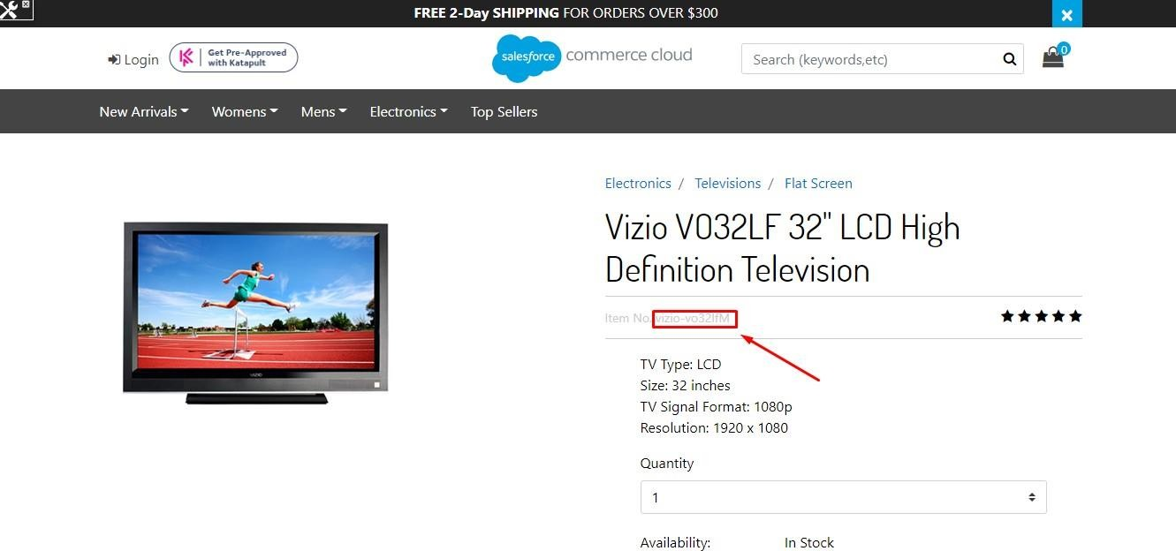

Click on the ID

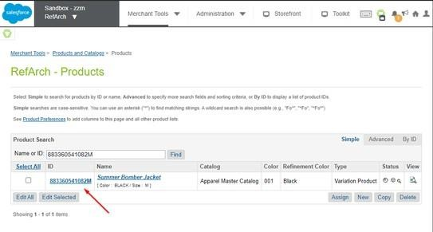

Click **Lock** to be able to edit the information of the product

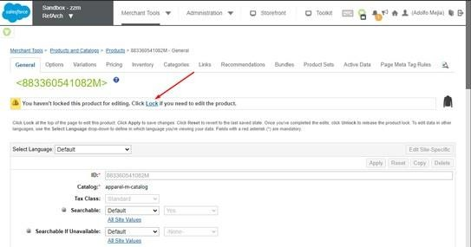

Scroll down to see all the attributes from the product and you will see the Katapult property, for default is **NONE**, the product is **NOT LEASABLE**

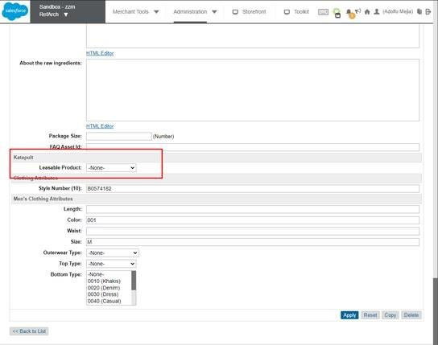

To enable the product as **LEASABLE** change the value to **YES** and press **APPLY** button

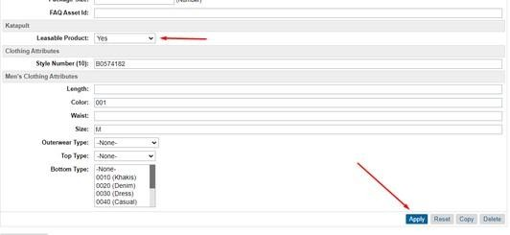

Once the product selected is set as **Leasable** product, proceed to add it to Cart

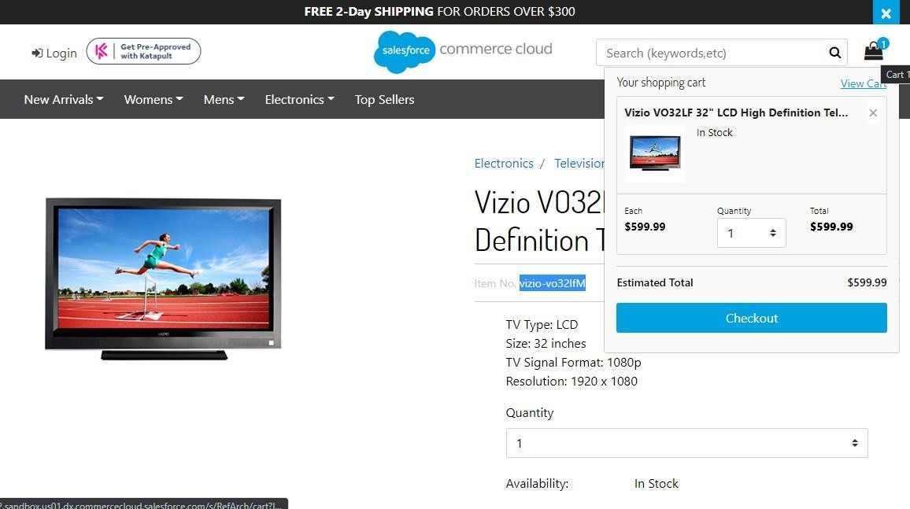

Steps to set multiple products as Leasable product, Click on Edit ALL or Edit Selected

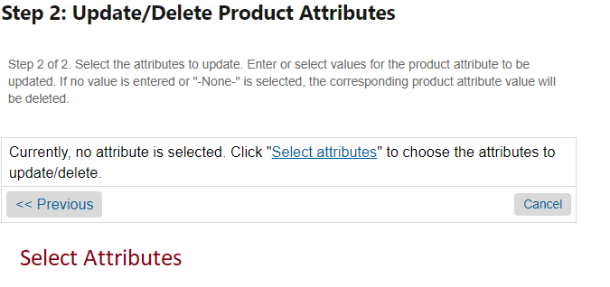

**Select Kat_isLeasable and click on Select.**

**Select Yes as Leasable Product and Click on Proceed and Return to Products**

Go to the checkout proccess as a Guest user or login with an account

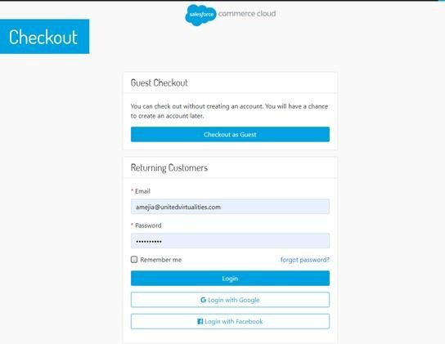

Fill the Shipping information and press **Next: Payment** button

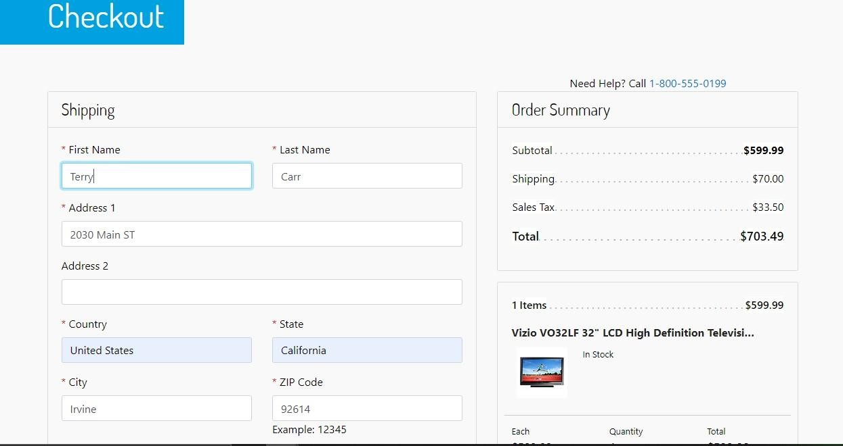

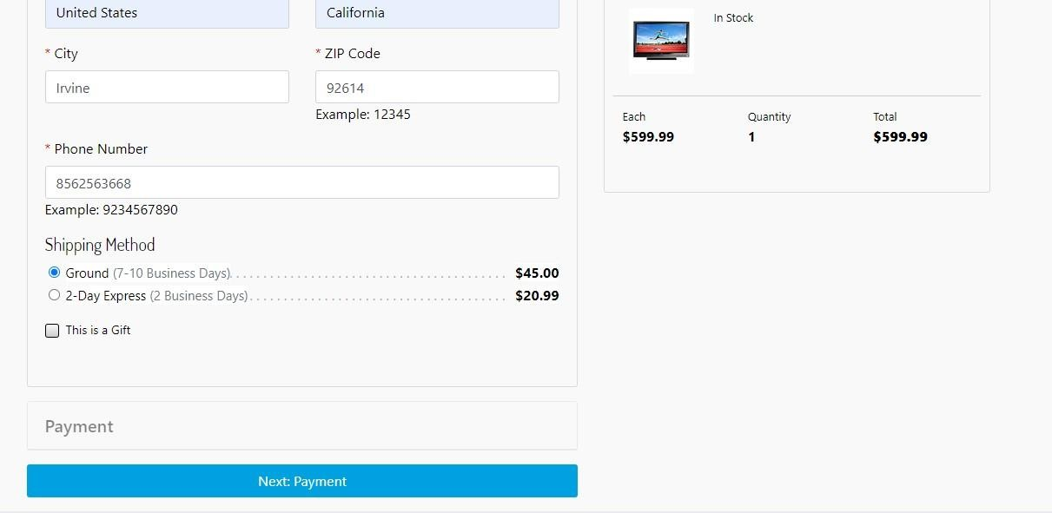

Set the billing information, if is not the same of the Shipping, press **Update address** and fill the inputs

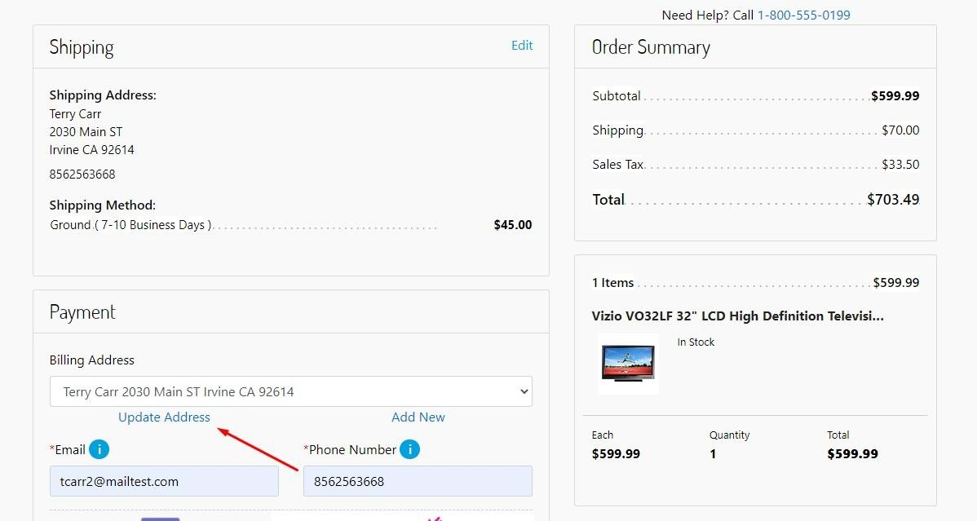

Once is set the Payment information, select the **tab** for the **Katapult payment method** and press **Next: Place Order** button

**Note**: A Custom object **katapult_transactions** is used to handle multiple sessions and link Katapult Order to SFCC Order, after that it will be cleaned, but is mandatory to have this CO on your instance to be able to perform Katapult orders.

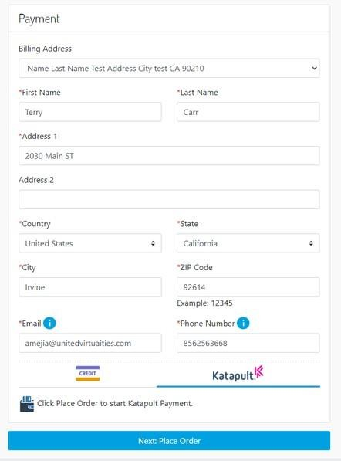



If all the products selected are not leasable the tab for the Katapult payment method will not be displayed

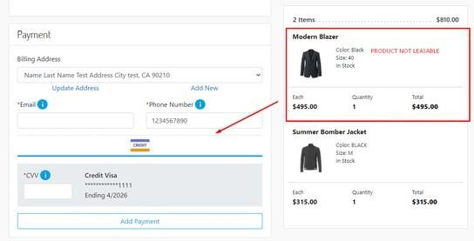

# Verify Orders Once Order is Created Using Katapult

In the Business manager go to **Merchant Tools > Ordering > Orders**

Open an order

Go to the **Payment** tab and verify the Payment method

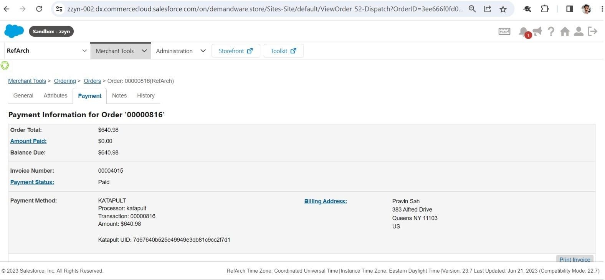

Go to the **Attributes / Payment tab** and you will see the Katapult information



**DO NOT** modify any of this information

